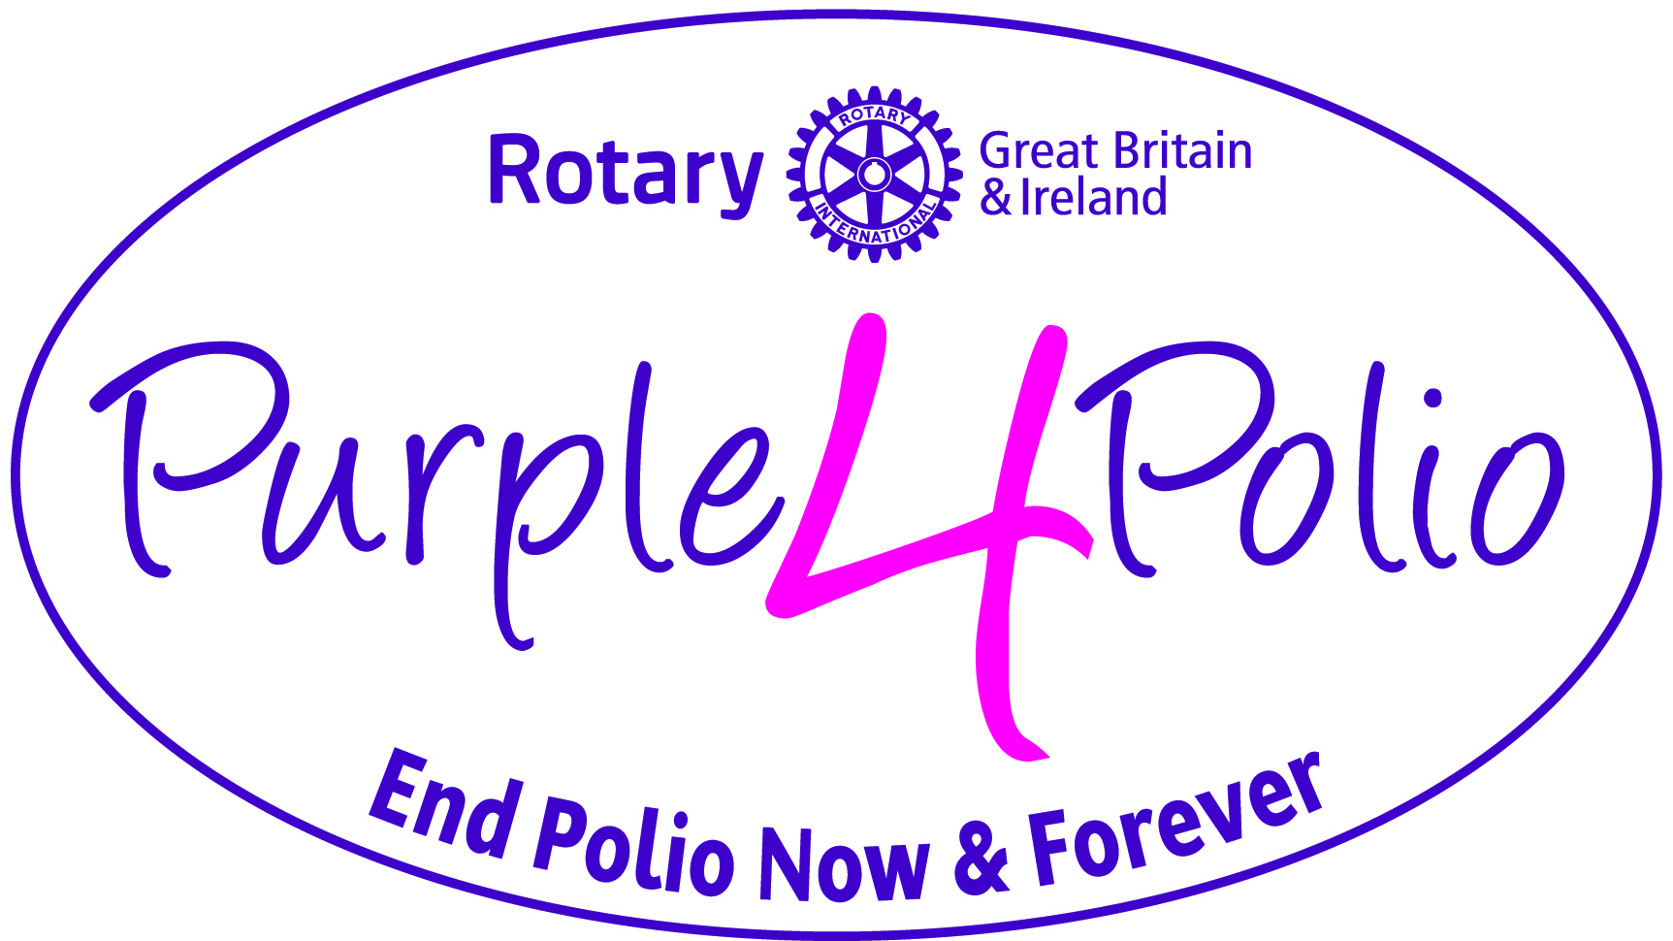

HELP ROTARY wipe POLIO off the face of the earth

NEWS RELEASE

(Please note: this is an outline draft press release for clubs/districts to adapt for your own events and activities. Red text is for clubs to edit. Please remove this paragraph before issuing the release.)

[NAME/CLUB] of [TOWN/CITY] is highlighting historic progress towards a polio-free world by [insert event headline] and is urging the local community to support them by [insert what you want the public to do].

Rotarians throughout Britain and Ireland are holding many Purple4Polio events to bring awareness of and raise money for the Rotary campaign to End Polio Now and forever.

Purple is the colour of the dye placed on the little finger on the left hand of a child to show they have been immunised against polio, hence the name Purple4Polio. With millions of children to vaccinate, this makes it easier to see who has been protected and who has not.

With your support here in [insert Town/City] you will be helping to make history by joining millions of Rotarians and supporters across the globe raising awareness, funds and support to wipe polio off the face of the earth. Polio is a vaccine preventable disease that still threatens children in parts of the world today.

The world has have never been closer to making history and fulfilling Rotary’s goal of a polio-free world with just 3 [UPDATE NUMBER IF NECESSARY, LATEST FIGURES CAN BE FOUND HERE http://polioeradication.org/polio-today/polio-now/this-week/] cases of wild poliovirus worldwide so far this year.

[Rotary International in Great Britain and Ireland is again joining forces with the Royal Horticultural Society to plant millions of purple crocus corms across Britain and Ireland, adding to those planted in recent years, as part of our Purple4Polio campaign to raise awareness and funds for End Polio Now.

Rotary members will be teaming up with Britain in Bloom Bloom Groups and other RHS community gardening groups, other community groups, [NAME THEM] sporting club, sporting personality [change as necessary] to plant the corms in public spaces to bring a splash of colour for all to see.]

[Details of the event including day / date / time / venue / what is happening / how you want the public to get involved / contact details for the event / buying tickets etc.etc.]

WHO: Rotary Club/District details
[Insert date and time]
WHERE: Location

Since Rotary and its partners launched the Global Polio Eradication Initiative nearly 30 years ago, the incidence of polio has plummeted by more than 99.9 percent, from about 350,000 cases a year in 125 countries to just 22 cases in 2018 and with just three remaining polio-endemic countries, Afghanistan, Pakistan and Nigeria.

To sustain this progress and protect all children from polio, Rotary has committed to raising US$50 million per year over the next three years in support of global polio eradication efforts. The Bill & Melinda Gates Foundation will match Rotary’s commitment 2:1 so every £1 becomes raised £3. Without full funding and political commitment, this paralysing disease could return to previously polio-free countries, putting children everywhere at risk.

[QUOTE FROM ROTARY MEMBER ORGANISING THE EVENT]

Rotary has contributed more than US$1.7 billion to ending polio since 1985, including [LOCAL FUNDRAISING FIGURES] contributed by the Rotary Club/District of [LOCAL CLUB OR DISTRICT NAME].

-ENDS-

Note to Editors:
For press enquiries contact:
CONTACT:
NAME: EMAIL, Phone number
CLUB/DISTRICT WEBSITE
CLUB/DISTRICT FACEBOOK PAGE
CLUB/DISTRICT TWITTER ACCOUNT

About Rotary International in Great Britain and Ireland

Rotary International in Great Britain and Ireland is a membership organisation where members use their skills and time to improve the lives of others locally and globally, while building friendships and having fun in the process. There are nearly 1,800 Rotary clubs across Great Britain and Ireland and about 50,000 members.

Rotary International was founded in 1905 in Chicago and is now the world’s largest membership and international service organisation with over 1.2 million professional men and women as members. There are 35,000 clubs in more than 200 countries and geographical areas.

Website: www.rotarygbi.org
Facebook: Rotary International in Great Britain and Ireland
Twitter: @RotaryGBI

