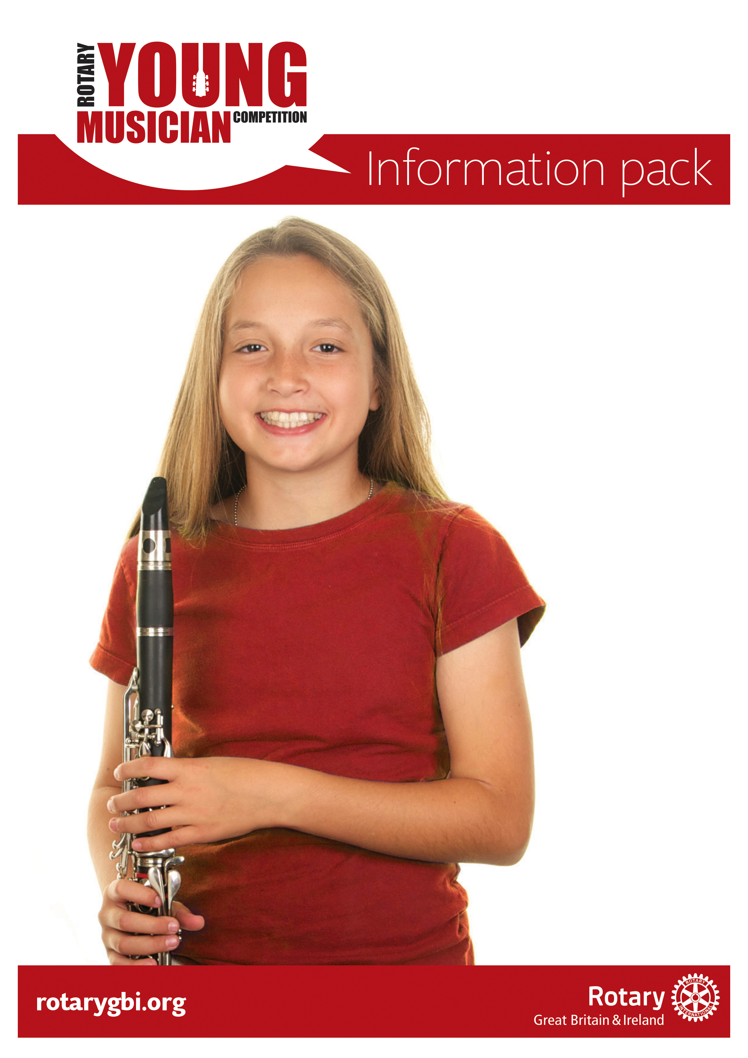
Information Pack for 2018 – 2019

Content

Introduction Page 2

Aims and Objectives Page 2

Who Can Take Part? Page 2

The Four Stages of the Competition Page 3
- Local Heats
- District Finals
- Regional Finals
- National Final
Competition Guidelines Page 3 - 4
- Format
- Adjudicators
- Prizes

How to Enter Page 4

Competition Procedure Page 4 - 6
- Arrival
- Results

Youth Competitions Page 6

Working with Children Page 6

Information Pack for 2018 – 2019

Introduction

The National Young Musician Competition is a well-organiser established and successful competition promoted by Rotary International in Great Britain and Ireland.

There are four stages to the competition, each designed to support and encourage the development of musical talent. Some stages may have more than one round.

The competition is open to all levels, grades and styles of young instrumentalists and vocalists.

Aims and Objectives

The competition aims to offer young people:

- the experience of performing on a public stage
- an opportunity to showcase their musical talent
- impartial feedback and assessment of their performance by experienced adjudicators

Who can take part?

The competition is open all schools and college communities, including those that are home educated and any other young people’s community organisations, for example, community RotaKids, community Interact, Scout Groups, Girl Guides.

All students (amateur) should be in full time education up to the age of 17 on 31st August 2018. It should be noted that competitors may be 18 at the time of some or all stages of the competition e.g. a competitor who is 17 on 31st August but turns 18 on 1st September may enter.

Students should enter the competition organised by the local Rotary Club through their respective group as detailed above. Individual requests by teachers or other individuals should not be accepted.

Competitors, schools, colleges, and organisations may participate in a District competition that is outside their geographical boundary but may compete in only one club or District competition.

Please note this competition is intended for amateurs; for the purpose of the competition, an amateur is considered to be a person whose main source of income is not made from musical performances, although there may be occasions when the receipt of occasional out of pocket expenses or prizes may be received. The competition is not open to full time students of music or performing arts, studying for a qualification above A Level or equivalent.

There are two categories in the competition:
- solo instrumental
- solo vocal

The Four Stages of the Competition

Local Heats
Organised by local Rotary clubs and hosted by schools or colleges between September and December. The winners of each category are entered into the district finals.

Local Rotary clubs may be found by using the club finder facility in the dialogue box “Find My Nearest Club” in the Home Page of the Rotary International in Great Britain and Ireland website www.rotarygbi.org/

District Finals
Organised by Rotary Districts between January and mid-February. In the case of high numbers of entrants, it may be necessary to hold preliminary rounds prior to a district final. The winners of each category (and, at the discretion of the organisers, the runners-up) are entered into a regional final.

Regional Finals
Organised by Rotary between mid-February and March. The winners only of each category are entered into the National final.

National Final
The 2019 National Final: Saturday, 4th May 2019 at Colchester Institute, Sheepen Road, Colchester, Essex, CO3 3LL

It should be noted that RIBI does not fund any expenses of the regional winners to attend the National Final.

The dates for local heats, district finals and regional finals may have local variations. Interested parties should check dates with their local Rotary Club in the first instance.

Competition Guidelines

Format
This is a competition at which competitors are judged within the context of a live performance. No recorded medium, in any format, will be considered and in Regional and National Finals will not be accepted. Competitors perform a selection of works of their own choice.

Competitors may perform the same pieces/songs in each and/or subsequent stages.

Competitors may perform from memory or from music at any stage. In the case of vocal candidates, it should be remembered that part of the assessment of the performance concerns communication with the audience and performing from a copy of music may prevent candidates from achieving this criterion to the fullest extent.

Competitors should be accompanied by a single instrument in sympathy with the performance; vocalists may accompany themselves. In the case of vocal, guitar and percussion candidates only, CD backing tracks are permissible. However, the backing track must not contain the part being performed by the competitor; in such cases where the backing track does contain the part being performed by the competitor, the judges will disqualify such candidates from the competition. Backing tracks are solely the responsibility of the competitor who must provide the performing medium (audio player, amplifier etc) and who will be permitted to have someone to operate the equipment. This will not be the responsibility of the organiser.

There may be occasions when the context of a performance does not require an accompaniment e.g. in the context of traditional folksongs or music written expressly for solo instrumental performance such as J. S. Bach’s Cellos Suites or Debussy’s ‘Syrinx’ for solo flute. In such cases, candidates would not be expected to ‘manufacture’ an accompaniment never intended by the composer.

An acoustic piano, either a grand or upright (the organisers having established which is the most suitable and appropriate) will be provided for competitors or accompanists at all stages of the competition. No other instrument will be provided. Competitors must provide their own accompanists; no ‘official accompanist’ will be provided

It should be noted that competitors offering solo piano do not require an accompaniment. Competitors offering solo piano should not have any other instrument playing. This would make the performing ensemble a duo, trio, quartet etc. and would not satisfy the competition criteria of ‘solo instrumental performance’.

If a competitor provides an electrical instrument the competitor must present an up to date PAT certificate to the organiser on the day of the competition. Failure to do so will disqualify the competitor from the competition.

Adjudicators
Persons with appropriate skills will be appointed by Rotary.

For regional or national finals, a Rotarian will not be appointed as an adjudicator.

The adjudicators will judge each performance according to:
- Melodic & rhythmic accuracy
- Intonation
- Tempo & flow
- Tone
- Mood and character
- The appropriateness of the programme
- The holistic view of the performance on the day

The adjudicators will not enter into any discussion or correspondence regarding their decision; the decision of the adjudicators will be final and not subject to any appeal.

Prizes
At all stages of the competition, competitors will receive a certificate of participation.

After the judges have determined the result of the competition, one or more judges will comment on their observations before announcing the results.

At the National Final, a trophy will be presented to the winner in each category.

How to enter
To enter a local heat contact your local Rotary club which can be found by visiting www.rotarygbi.org. In case of difficulty, contact the national organiser at young-musician@rotarygbi.org quoting the address of the school/organisation.

Entrants need to complete an entry form and submit it and other information required to the stage organiser by the time specified.

Competition Procedure

Arrival
Before each competition, the competition organiser will conduct a draw to determine the order in which each competitor performs. The order of performance will be notified to competitors either before or at the competition. In unforeseen circumstances, the organisers reserve the right to make adjustment on the day if the need arises.

Competitors must provide three copies of their selected works for the adjudicators. Competitors failing to do so will be adjudicated but the assessment may be adjusted accordingly. It should be noted that competitors playing guitar must submit copies in staff notation: tablature is not an acceptable alternative, although competitors may play from tablature. Photocopying facilities will not be available at the competition venue. Copies will be required at least two weeks prior to the National final.

Photocopies of music published as individual pieces will not be permitted unless competitors can provide written permission from the publishers.

Photocopies of music not published as individual pieces but in an anthology, will be accepted provided the competitor has a copy of the original publication.

All photocopies will be retained and destroyed by the organiser immediately after the event.

Cuts to competitors’ parts are not permitted.

If there are any variations to or extemporisation in the competitors’ parts, they must be clearly marked in the copies for the adjudicators. Any extemporisation of 20% or more is likely to affect the adjudicators’ assessment.

Cuts to the accompaniment should be avoided. However, cuts are permissible to edit long introductions or long passages in the accompaniment where the competitor is not involved. Any cuts to the music must be clearly marked in the copies for the adjudicators.

Performance A master of ceremonies will invite each competitor in order of the ballot, to come to the front or stage to perform.

Competitors may introduce their selection of works.

The selection of music should consist of a minimum of two pieces in contrasting styles which may be differing movements of the same composition.

It is recommended that performers include some variety of style and musical period in their choice of music. The balance of the programme will be taken into consideration by the adjudicators in the event of a tie.

In the instrumental category, except for percussion, competitors should play only one type of instrument. Percussionists may combine tuned and untuned percussion in their performance but this is not compulsory.

Vocal competitors should select songs suitable for a family audience, giving due consideration to the appropriateness of the lyrics.

The time for competitors’ performance should not exceed 10 minutes. The timing should begin when the competitor first begins to play. The adjudicators will not judge that part of the performance after ten minutes’ duration.

The performance time for Local Heats and District Finals may have local variations. Interested parties should check performance times with their local Rotary Club.

Amplification, although permitted, may not be provided by the organisers. Where the organisers do not provide amplification, performers must provide their own. In this case, an up to date PAT certificate must be presented to the organisers. This must be indicated clearly to competitors.

Photographs must not be taken, and audio and video recordings must not be made by anyone other than those nominated by the organiser.

Results
After the adjudicators have determined the result of the competitions, one or more judges will comment on their observations before announcing the result.

Youth Competitions
The Young Musician competition is one of seven competitions for young people organised by Rotary International in Great Britain and Ireland. The others are Young Chef, Young Photographer, Young Writer, Youth Speaks, Young Citizen Awards and the Technology Tournament. To find out more about these competitions and other opportunities for young people, please contact your local Rotary Club or visit www.rotarygbi.org.

Working with Children
Rotary International in Great Britain and Ireland has adopted this statement of policy in working with children, the vulnerable and those with disability:
The needs and rights of the child, the elderly, the vulnerable and those with disability take priority. It is the duty of every Rotarian to safeguard to the best of their ability, the welfare of and prevent the physical, sexual or emotional abuse and neglect of all children, the elderly, persons with disability or otherwise vulnerable persons with whom they come into contact during their Rotarian duties.

