Rotary District 1220  Business Partnership  Eco Bottle Greenhouse  Project Guide  Version 3 Dated 17th November 2018 | 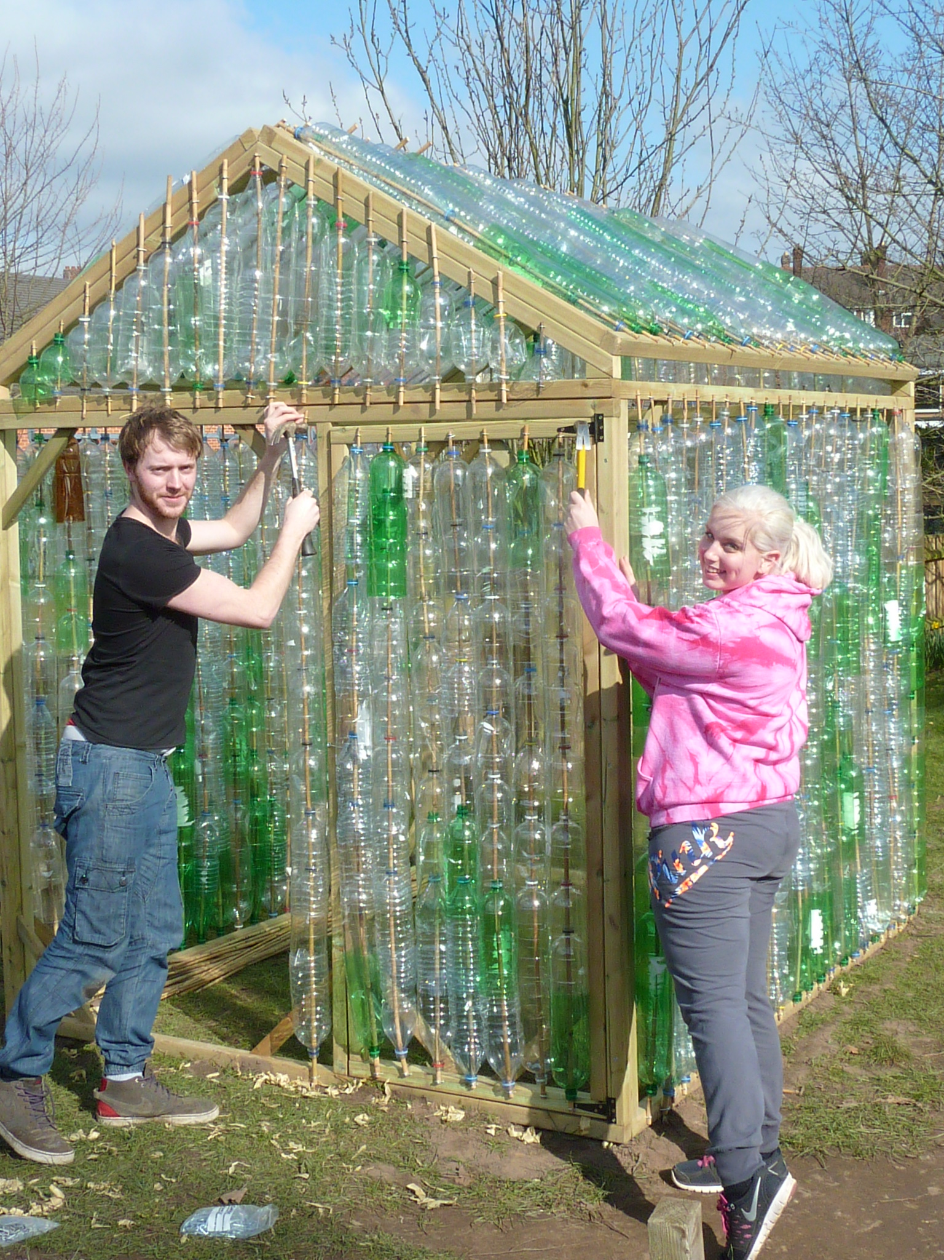
Author: David Pedlar
Rotary District 1220
Business Partnership

d.pedlar@ntlworld.com

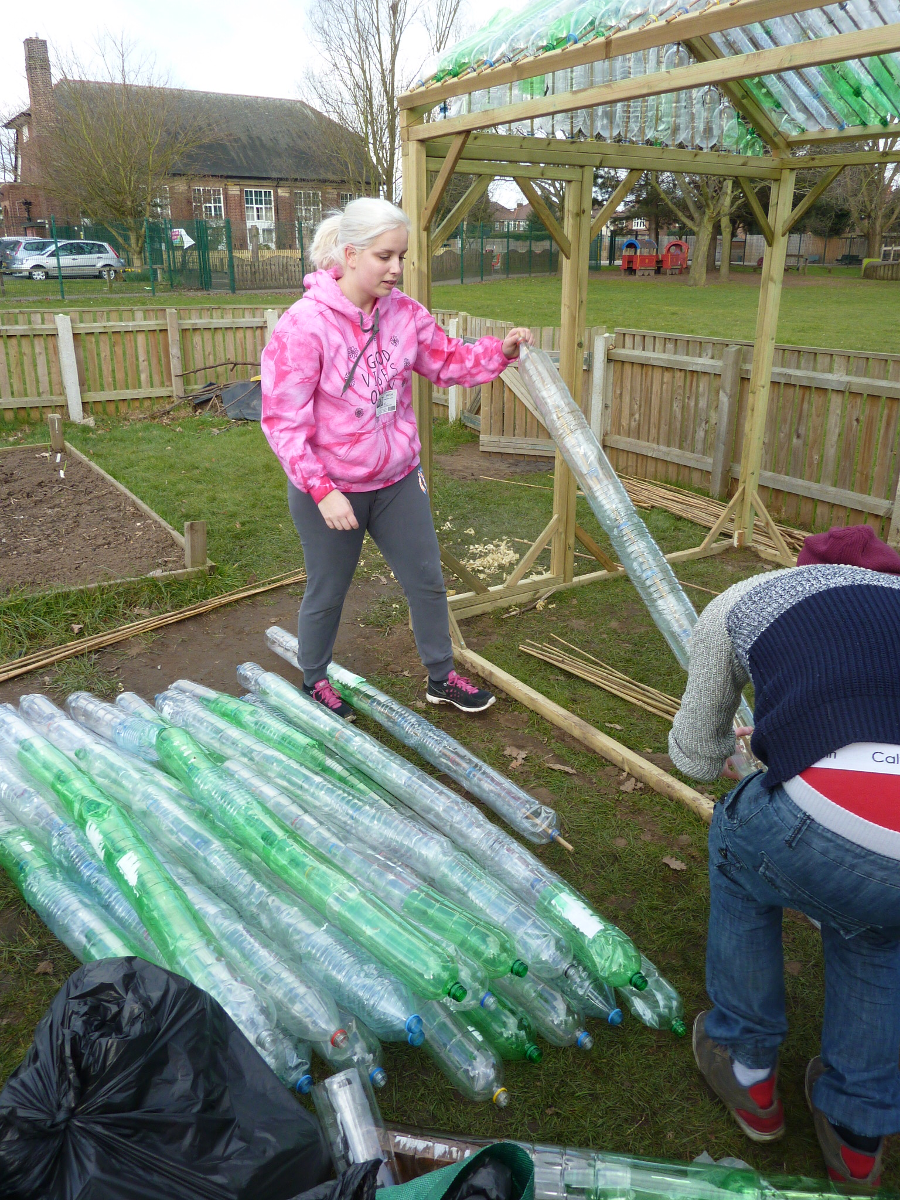
Executive Summary
The District 1220 Business Partnership has successfully established a project that ticks all the boxes for schools and business but most importantly enables Rotary Clubs to engage with people in the working age group and identify prospective new members.
The Eco Bottle Greenhouse project helps schools meet National Curriculum guidelines. Schools have limited funds and so they need our help to fund and build these valuable additions to the education system. We have joined forces with a manufacturer of school equipment to supply each greenhouse kit at a cost of £295 +VAT. The children collect the plastic bottles and learn about recycling.
With a volunteer force requirement of 4 people for 2 days it is ideal for small companies to achieve their Corporate Social Responsibility (CSR) objectives without a huge commitment.
Your Rotary club can broker these projects and make a difference for schools and the business community.
The real bonus for Rotary is the enthusiasm that we are finding from the teachers who see the value of Rotary in their schools. We are already getting feedback to suggest that they would join Rotary to further their school ecology projects, assist their personal networking and open doors that only Rotary can offer
Table of Contents
- Executive Summary 1
- How to get started 3
- The role of the Rotary Club
- Approach to local schools
- Funding
- Finding Business Partners

- Planning 4
- Ordering greenhouse
- Schools involvement
- Construction team
- Risk assessment
- Insurance

- Construction 5
- Site location
- Allocation of time
- Construction guidelines

- Final actions 8
- Handover
- Follow-up
- Contact 8
- Appendices 9
- Appendix A – Order Form
- Sample Risk Assessment
- Basic Framework Assembly Drawing

- How to get started
Once a club has decided to go ahead it is recommended that a small group form a Business Partnership committee to oversee the project(s). The Junior section of a Primary school is the most likely to benefit from an Eco greenhouse but it is possible that other age groups may be interested. The project can be approached in various ways but the process needs to cover the following elements:
- The role of the Rotary Club
The primary role of the Rotary Club is to act as the brokers between the school and business partners. It is not the intention that Rotary members undertake physical work but of course enthusiastic members may wish to be involved in construction. It will be necessary for at least one member to oversee construction using information provided in this and other documents. This is a simple project and it is recommended that a small team of 2 to 4 Rotary members is formed to deliver the completed projected.
- Approach to local schools
It is recommended that a meeting with the Head Teacher, or a teacher responsible for Eco education, is set up. Using information material available from the D1220 BP Team discuss the opportunity that Rotary is able to offer. If the school sees it as a benefit then arrange for at least one teacher to be the regular point of contact throughout the project.
- Funding
The project can be funded by the Rotary Club but it is preferable if a Business Partner is found for that purpose as it enables them to fulfil a CSR objective by paying for the greenhouse as a benefit to the local community.
- Finding Business Partners
Potential Business Partners can be found within any community. In our experience most of the High Street supermarket chains are very keen to get involved. This can range from the small local stores such as Sainsbury’s Local that will have an area manager as the best point of contact through to the larger supermarkets who will probably have a community liaison officer. This project can easily be undertaken by a small team drawn from local businesses whether they are on the High Street such as solicitors, banks, building societies, shops or on local trading estates. Getting volunteers from more than one company is also beneficial to them as it helps with networking amongst the business community. The business partner may wish to fund and construct the greenhouse.
Contacting a local Chamber of Commerce or Business Club can also be sources for potential Business Partners.
- Planning
The next phase is to establish the programme with all the parties involved.
- Ordering greenhouse
The greenhouse needs to be ordered a month before the assembly date. This should be made to RSJ Play Ltd. on the Rotary order form in Appendix A. It is possible for the school to recover the VAT if they place the order but it is important that the Rotary order form is completed and accompanies any other official order form that the school or a company is required to use.
- Schools involvement
The school children are expected to engage with the project by the collection of 1,300, 2 litre round plastic bottles. It is suggested that 50 , 1 litre bottles are also collected as these can be used in the two gable end sections. These will need their labels removed and the bottom cut off. This can be done by anyone, including the children, but needs to be completed by the time of assembly. Because of the quantity required it may be necessary to get more people involved with this item such as parents, families, club members etc.
- Construction team
The construction volunteers should consist of 4 people and we recommend that two days be allowed for the work although it is possible to complete the construction within 8 hours. A construction guide and video are available from the BP Team or can be found on the Facebook page Rotary Business Partnership Initiative. Insurance cover for all those involved on the construction site is important. Either ensure that the employees are covered by their employers insurance, including public liability, or register the volunteers as Associate members of your Rotary Club. The latter does not mean that any fees are involved but it does mean that they are covered by Rotary’s insurance.
- Risk Assessment
It is essential that Rotary produce a Risk Assessment for the project. This may be in conjunction with ones produced by the school and business partner.
In appendix B you will find a sample Rotary Risk Assessment.
- Insurance
Either ensure that the employees are covered by their employers insurance, including public liability, or register the volunteers as Associate members of your Rotary Club. The latter does not mean they any fees are involved but it does mean that they are covered by Rotary’s insurance. It is worth contacting Rotary’s insurers to register the project and confirm that cover is provided.
The following information from Rotary’s Insurers was correct at the time this was written.
1. Combined Liability – covering legal liability for death or injury to club members, volunteers and/or members of the public and legal liability for damage to their property. The Limit of Indemnity is £20M.
2. Automatic cover has been agreed with the insurer for low hazard DIY work that does not involve specialist tools, machinery or equipment. We understand this to include the greenhouse construction.
- Construction
It is recommended that one member of the management or construction team has some DIY skills.
- Site location
Clarify with the school the exact location of the greenhouse and its orientation. Ensure all the necessary tools that are recommended in the guide are on site or made available. Co-operating with the school caretaker is very helpful throughout the project. It will be necessary to ensure the ground is flat before construction starts but note the greenhouse can withstand a slight slope if it is impractical to level the ground.
- Allocation of time
To finish the frame and roof (bottles on the roof only) takes 4 people 4 hours.
To fit the bottle to the sides and ends takes 4 people 4 hours.
It is suggested that the first day is programmed for the assembly of the framework and the complete assembly of the roof section including fitting the bottles. 300 bottles are required for the roof so it is possible to get day one completed before all the bottles are collected. The second day is used to complete the fitting of the bottles to the main framework and final fitting.
- Construction guidelines
Tools required: Spade, Tape measure, 2 hammers (1 large to drive pegs into the ground), spirit level, step ladders, a fine tooth saw/hacksaw, pincers, large sturdy scissors (for bottle cutting). A battery operated screwdriver for the frame fixing and drills bits.

We recommend watching the construction video which can be found on our Facebook page.

- The frame kit includes all the frame timber with pilot holes for all screw fixings, 140 x 1800mm Bamboo canes, staples, screws, hinges, hasp and staple. The door fixes into position in one of the end frames. Note: On hard standing e.g. slabs, concrete or tarmac alternative fixings, not supplied, will be required.
- Plastic Bottles, 2 litre. The children collect 1300. The children collect them, wash them and take the labels off and cut off the bottom 2 inches. There is an option to use 1 litre bottles on the two gable end sections of the roof for ease of fitting. Approximately 75 bottles will be required
- Preparation:
- All frame members are checked against the Materials List and individually marked for ease of identification and use during the assembly process.
- There is at least one Rotary member in each team to minimise the 'learning curve' of the BP volunteers.
- We recommend that Rotary members are 'hands-on' rather than in a supervisory capacity (its more engaging anyway if you are working rather than just watching);
- We recommend teams work simultaneously on separate elements of the assembly - roof, walls, bottles preparation/threading onto canes. The teams then work simultaneously on bottle fixing to three separate walls.
- Frame Assembly:
Step 1
Assemble 1 side frame using 2 x long horizontal rails (C), 2 x long vertical rails (A) and 8 x fixings (1).
Ensure the frame is square by measuring diagonally from corner to corner. When both diagonals are the same the frame will be square.
Fix 4 x long braces (E) to the corners using 8 x fixings (1). . Check that the 4 corner braces are flush on the same side of each frame.
We recommend the second side frame is constructed on top of the first frame as it creates a firm square base to work from.
Assemble the side and end frames. Measure diagonally across the corners and tap them to ensure the frames are square then screw the corner braces into position Assemble the completed sides and ends to form the greenhouse (ensure that the ends are placed according to the sketch).

Step 2
Assemble the back frame using 2 x short horizontal rails (D), 2 x short vertical rails (B) and 8 x fixings (1).
Ensure the frame is square.
Fit 4 x long braces (E) using 8 x fixings (1).
Assemble the front frame using 2 x short horizontal rails (D), 2 x short vertical rails (B) and 8 x fixings (1).
Decide where your door is going to be positioned to the left hand or right hand side and fit another short vertical rail (B) using 4 x fixings (1).
Note: Door can be fitted to the left hand side or right hand side and positioning of long braces (E) is depended the positioning of your door.
Fit 2 x long braces (E) using 4 x fixings (1) to the corners that the door will not occupy.

Step 3
Assemble door using 2 x door side rails (M), 2 x door top and bottom rails (N) and 8 x fixings (1). Fit 4 x short braces (H) using 8 x fixings (1).

Step 4
Fit door to front frame using 2 x fittings (2) and fit catch (3).

Step 5
Assemble roof frames using 4 x roof long rails (F), 4 x roof short rails (G) and 16 x fixings (1).
Fit 8 x short braces (H) using 16 x fixings (1).
Assemble roof apex frame using 2 x apex bottom rails (J), 4 x apex rails (K) and 12 x fixings (1).
Note: For easier fixing we recommend that you fix your recycled bottles and canes to the roof of your Rotary Eco-Green house at this stage. Fit the bottles (300) on the canes and staple to the roof, necks facing upwards except the bottom bottle which faces downwards. The exact number of canes need to be cut to size for the top frames so measure one cane and cut the rest to size before threading the bottles. It’s easier with a fine saw or a hacksaw. Use the valley of the roof as support. Save the cane off-cuts for the gable ends.
On the gable ends you will have to use the cane off-cuts and cut them to size to accommodate the slope of the roof. You will also have to cut the bottles to fit. (Try 1 litre bottles instead of 2 litre for ease of fitting).

Using 4 people lift complete roof into position and fix using 4 x fixings (1).

Step 6
Fit together 2 x side frames and front and back frames using 16 x fixings (1).
At floor level assemble the 2 x roof assemblies to the 2 x apex assemblies using 8 x fixings (1).
Hammer the ground supports on the inside of the greenhouse base midway along each side and ends. Screw them to the base frames.

Thread the bottles and attach to the side and end frames. The bottles nest into each other but make sure that the last one on the cane is nested with the neck pointing out/down. (The necks face upwards except the last one which is neck down). This allows water to drain over and through the bottles
Note: It is advised that step 6 is carried out by an adult or with an adult in attendance.

Step 7
On soft ground hammer in ground fixings (L) (supplied) and fix to greenhouse using 8 x fixings (1).
Fit a Rotary badge to the greenhouse.

- Final Actions

- Handover
On completion of the project it is necessary to have a formal handover for public liability purposes as well as a general acceptance of the greenhouse. This is also an ideal time to invite the local press and other people to maximise the publicity opportunity that the project offers.
- Follow-up
The ultimate objective of the project is to use the opportunity to identify new members. Teachers and parents at the school and volunteers from the Business Partners are all prospective candidates. It is entirely up to the Rotary Club how it addresses this but one possibility is the formation of a Satellite Club which could be established using the nucleus of teachers from a group of schools. The Satellite Club approach has the benefit of members delivering hands on projects without compromising the limited recreation time that teachers and young professionals increasingly struggle with. The most recent Rotary International changes to membership and attendance rules opens the opportunity to prospective new members who are more interested in undertaking projects and less on meetings.
- Contact details
If you want to unlock the door to this real opportunity for your club, at little cost, with little effort and no significant commitment from your members, you just need to contact a member of the District 1220 Business Partnership Team and we will assist you along the way.
For more information including construction video and assembly in pictures visit our Facebook page Rotary Business Partnership Initiative
David Pedlar, Chairman of the District 1220 Business Partnership Team and Eco Greenhouse National Co-ordinator
Email: d.pedlar@ntlworld.com Tel. 01158751484; Mobile 07866164308

Appendix A
Rotary Eco Greenhouse Order

Important Note:
This order form is for the purchase of the Rotary Eco Greenhouse from RSJ Play Ltd.
If it is necessary to provide a separate purchase order, please ensure this form is completed and attached. This will enable the manufacturer to recognise the basis of the order.

Supplier:  RSJ Play Ltd.  3 Boscobel Road  Walsall WS1 2 PL  alex@rsjplay.co.uk  Tel: 01922 646845  Mob: 07929 344505 | Purchaser:  [Name]  [Company Name]  [Street Address]  [City, ST ZIP Code]  Tel:  Email:  Fax: | Ship to:  [Name]  [Company Name]  [Street Address]  [City, ST ZIP Code]  Tel:  Email:  Fax:

Please specify here participating Rotary Club [Name]

 | Description | Qty | Price
 | Rotary Eco Greenhouse
 | (Unit cost £295 +VAT inclusive of delivery to the UK except Highlands and Islands.)
 | (For delivery charge for the Highlands and Islands price on request)
 | TOTAL
Payment must accompany this order and cheques made payable to
RSJ Play Ltd.
Appendix B
Risk Assessment Template
ROTARY CLUB xxxxxxxx EVENT
SCHOOLS GREENHOUSE PROJECT
Date:
Event and Construction organiser : xxxxxxxxxxxxxxx
Risk assessment officer: xxxxxxxxxxxxxxx

Health and safety policy statement: Club members, volunteer helpers and other helpers will endeavour to ensure the safety of School Staff and pupils, all the members of the public, the Inner Wheel and Rotary Clubs. Display this statement at construction sites.

PROBLEM | HAZARD | PERSONS at RISK | CONTROL MEASURES | RISK LEVEL | ACTION
Transporting, carrying timber and other components | Back, shoulder injuries  Drop on feet  Trapped fingers, abrasions | Rotarians and helpers | The appropriate numbers of able bodied Rotarians to lift and carry (2-4 persons)  Break down pallet contents to individual components for ease of carrying  Use protective gloves and good footwear. | Medium | Advice from team supervisors  to assemblers to only lift light items by themselves and to employ the use of helpers for heavier loads.  N.B. Once broken down into component parts each part is light enough for safe carrying.
Assembling greenhouse frames | Frame timbers unstable and falling until fixed  Sharp corners to boards | Rotarians, helpers and persons standing in the vicinity | Need team of four including a supervisor. Only persons involved in the construction or dismantling to be in work area.  Ensure the frame is secured and safe before leaving. | High | Must be supervised.  Assemble sides and roof at floor level before bringing them together to form the greenhouse. Four persons needed to lift the roof into position.  Clear other persons from the final site before erecting and joining the frames
Leaving tools around | Abandoned tools on ground and other surfaces | All assemblers | Do not leave tools unsupervised.  Only use scissors for cutting. | High | Persons using tools to take care and team members to cross check
Observer control | Too close, distracting talk. | General public and helpers. | Limit personal engagement.  Keep observers at a safe distance. | Low | Duty Rotarian(s) to ensure people do not crowd in.
Frame collapsing | Inadequate fixings  Wind blowing and other poor weather conditions | General public, Rotarians and helpers | Ensure wood frames are stable when set up  Allow space around boards so viewers will not get too close and will not be jostled | Low | Regular checks by Rotarians.  Follow the construction plan.
Injury from use of tools | Fingers hit by hammer or cuts from sharp tools.  Splinters | Assemblers | Use scissors when cutting banding tapes and plastic bottles | Medium | Duty Rotarian to check that scissors are the only sharp tools used.
Slips, falls, faints, collapse | Injuries,  Medical emergencies | Rotarians, Observers and helpers | First aid equipment is available at the school. If medical assistance is required report to front desk and summon help | Low | Duty Rotarians to know where the first aid box is located.  Ensure a mobile phone is available for an emergency.  Keep a record of any incident.
Fire | Smoke inhalation, burns | All helpers and observers | Club members and helpers know fire drill. | Low | A duty Rotarian to guide all to the assembly point and liaise with school staff regarding situation
Clearing site and leaving | Left tools, debris and staples may cause injury. | Site users | Leave site clear | Medium | Arrange for designated persons to check completion and hand over to school representative.

Incident reports: check schools reporting system and ensure Rotary insurance cover for all helpers.
Assembly point: confirm with school a position away from the building.
First aid equipment: basic first aid box will be available at the school reception.

The School will have safeguarding procedures. All Rotarians and helpers MUST follow the procedures.

Appendix C
Basic Framework Assembly Drawing

