Rotary and the world needs your help to reach the ultimate goal of a polio-free world.
In 1985 when Rotary pledged to wipe out the life-threatening and disabling polio virus off the face of the earth over 1,000 children were affected every single day in 125 countries.
- There is absolutely no cure, but polio is entirely preventable with a vaccine
- Polio mainly affects children under age 5
- Until we end polio absolutely everywhere children all over the world are at risk
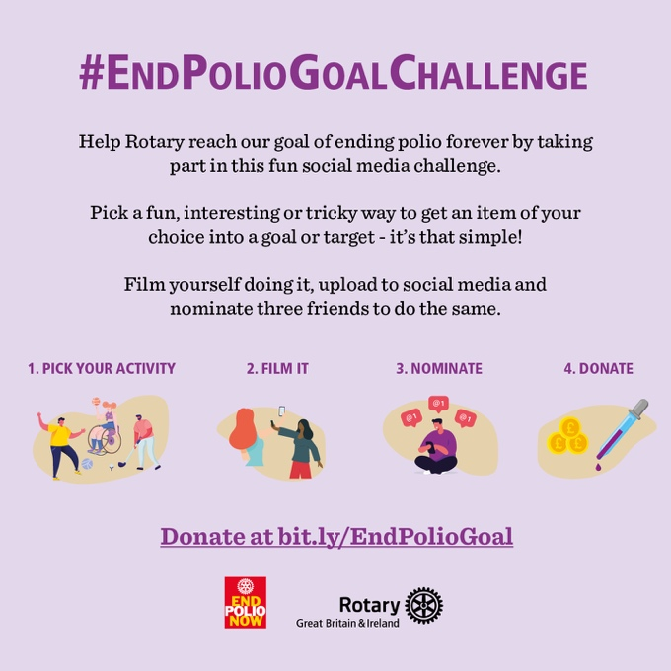
Will you have some fun and help spread the word about eradicating polio by taking the #EndPolioGoalChallenge and nominating 3 friends

Download the social media graphics at https://bit.ly/EndPolioGoalSocial

Tag Rotary GB&I in your posts:
- Facebook – @RotaryinGBI
- Twitter – @RotaryGBI
- Instagram - @RotaryGBI
The polio-virus is literally just a plane ride away but thankfully we have a vaccine. Much work is still to be done by Rotary and our partners in the Global Polio Eradication Initiative to reach the goal of a polio free world. Over 2 billion doses of polio vaccine are administered to more than 400 million children in around 50 countries every year.

The Polio programme’s legacy is so much more than just wiping the polio virus off the face of the earth. It has been invaluable in the Covid-19 response in many countries, helped stop ebola in Nigeria and immunised 8 million people against yellow fever to name just a few.

You can download these social media graphics to use on your own social media accounts and don't forget to use #EndPolioGoalChallenge and tag Rotary GB&I

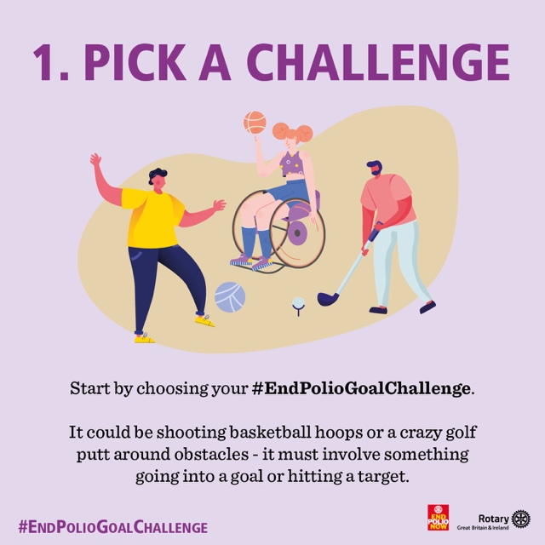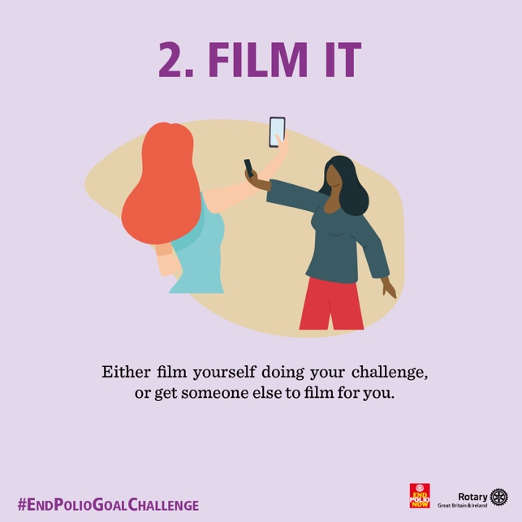

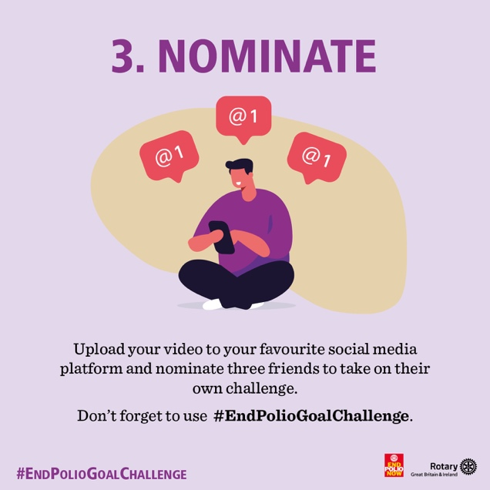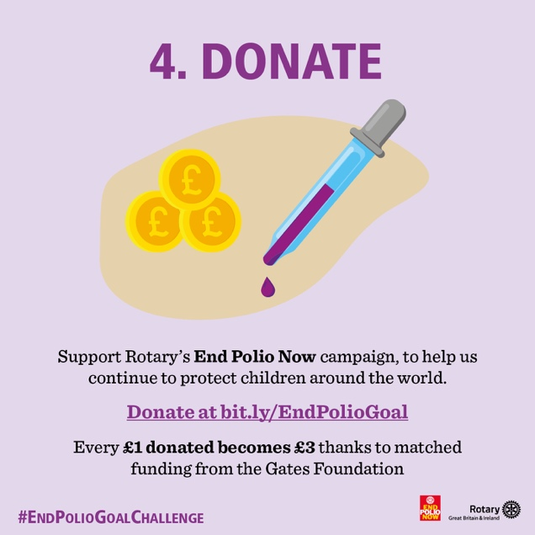

Find out more about Rotary’s End Polio Now campaign on our website.

THANK YOU

