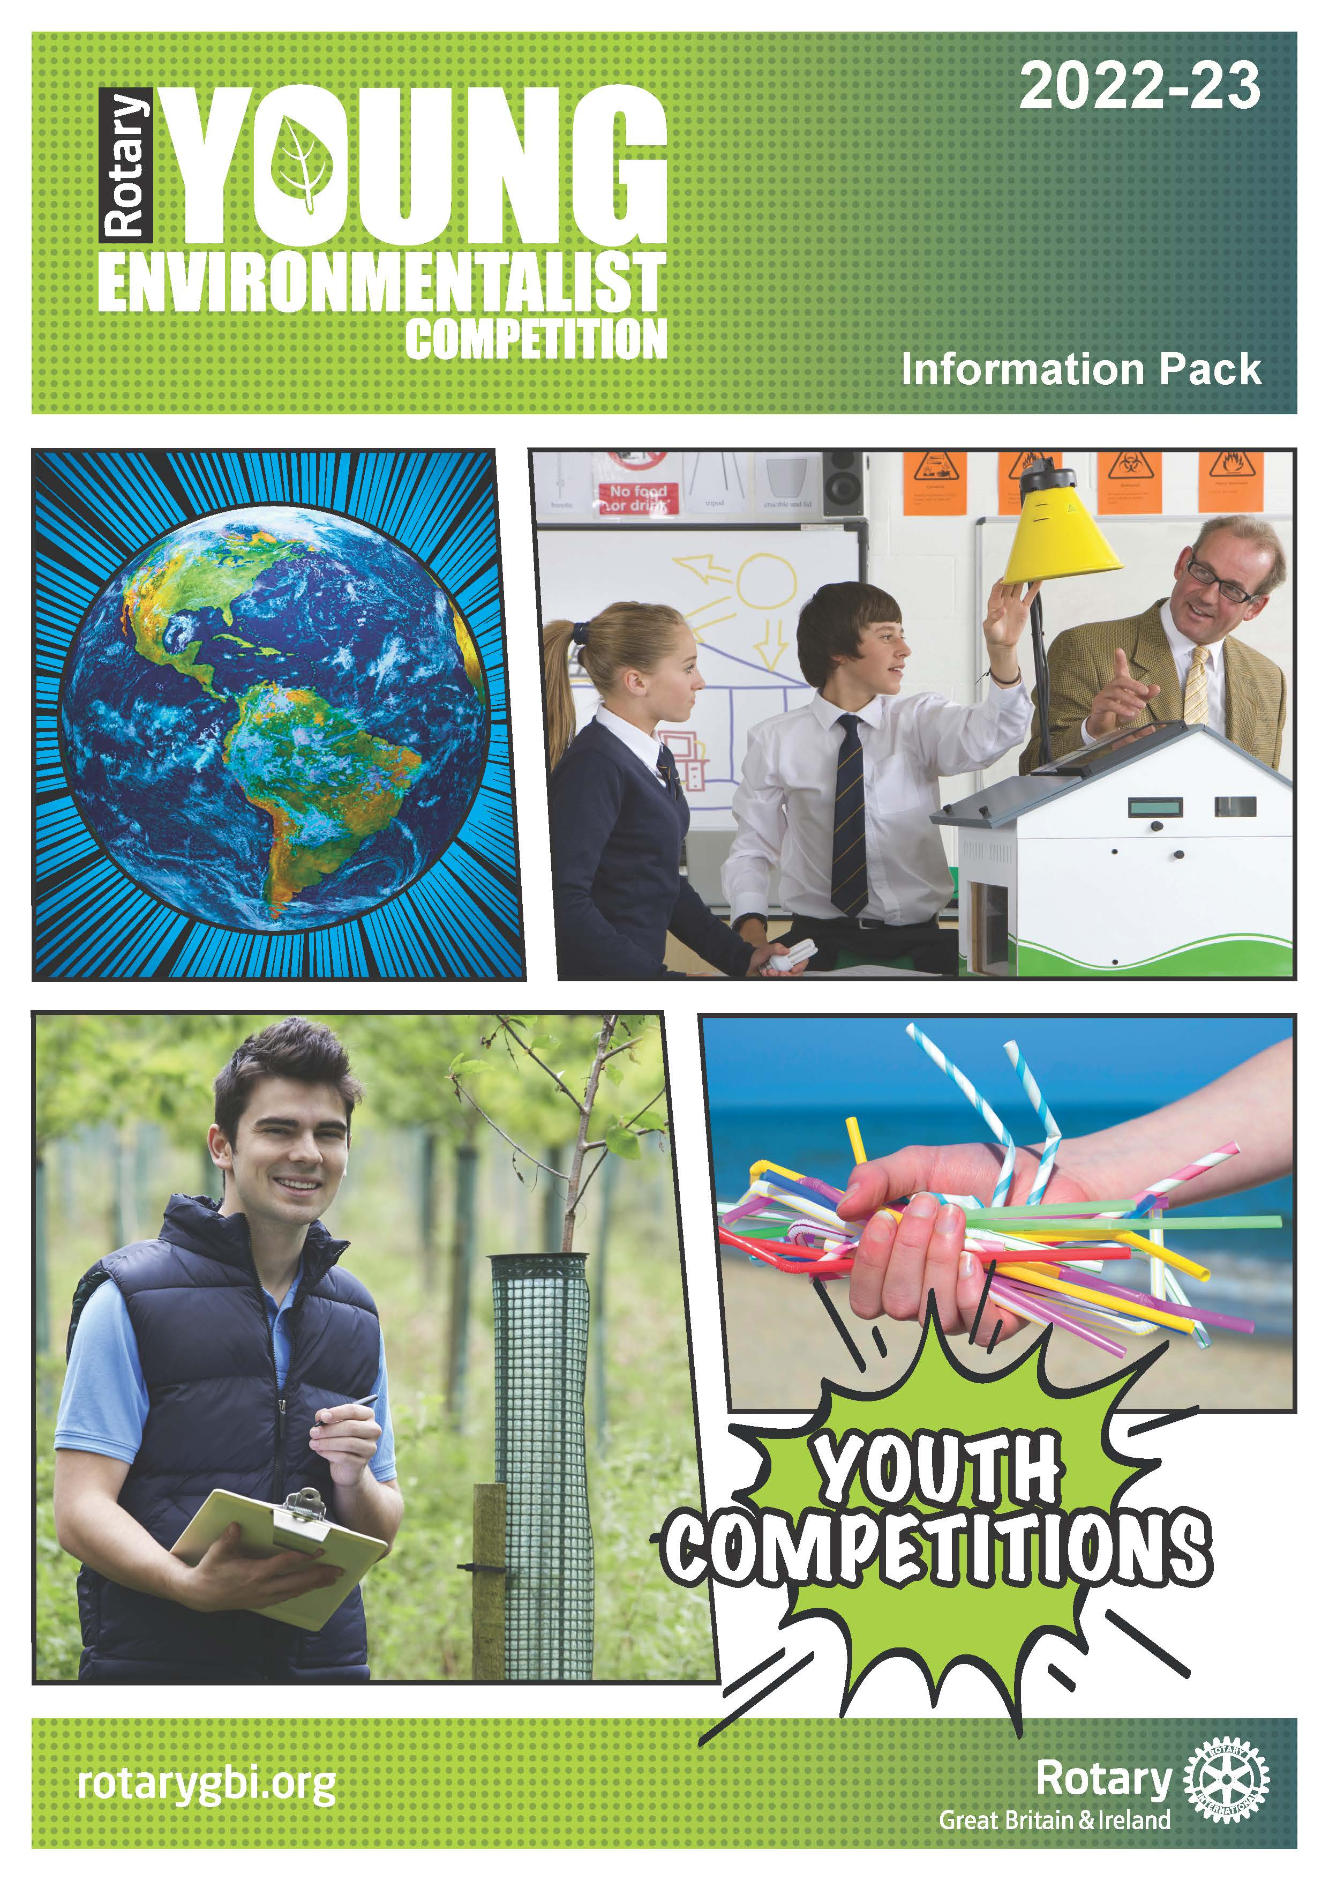

Young Environmentalist Information Pack

2022-23 Theme: Bio-diversity

Content:

Introduction Page 2

Aims and Objectives Page 2

Who Can Take Part? Page 2

The Three Stages of the Competition Page 3
- Local Heats
- District Finals
- National Final

Competition Guidelines Page 3 - 5
- Task
- Outcomes
- Presentation
- Judging Criteria
- Prizes

How To Enter Page 5

Rotary Youth Competitions Page 5

Working with Children Page 5

Information Pack for 2022 - 2023

Introduction

The Rotary Young Environmentalist Competition is a competition organised and promoted by Rotary International in Great Britain and Ireland (Rotary GB&I).

There are three stages to the competition, each designed to support and encourage the development of environmental skills. Some stages may have more than one round.

Aims and Objectives

The competition aims to encourage young people to:

- interact with the environment
- address serious environmental issues
- develop and explore solutions to the issues
- explore, investigate, research and undertake an environmental sustainability project

Who can take part?

The competition is open to all schools and college communities, those who are home educated, along with any other young peoples’ community organisations, for example, community RotaKids, community Interact, Community Groups, Scout Groups, Girl Guides, Church Groups etc.

There are three age groups:

Junior Up to and including 10 years old
Intermediate 11 to 13 years old
Senior 14 to 17 years old

Entrants must not exceed the upper age parameter for each group on 31 August 2022.

With the age qualifying date of 31st August 2022, it should be noted that some junior entrants may be 11, intermediate entrants may be 14 and some senior entrants may be 18 at the time of some or all the stage competitions i.e. a competitor who may be 17 on 31st August but turns 18 on 1st September is allowed to enter. Competitors must include their age on the application form.

Students should enter the competition organised by a local Rotary club through their respective group, as detailed above.

Competitors, schools, colleges and youth organisations and individuals may participate in competitions organised by a Rotary club or district outside of their geographical boundary but may compete in only one club/district event.

There are two categories in the competition in each age group
- An individual entry
- Group entries (maximum of four participants)

The Three Stages of the Competition

Local Heats
These are organised by local Rotary clubs with the winning entries in each age group are entered into a district competition. The local Rotary Club should notify the District Coordinator by 31st January 2023 of the intention to enter, and in the event of there being four entries or less in total in any age group within a District, these will automatically be entered into the District Round (see below). It is up to each District Coordinator of the competition to liaise with participating clubs to decide a date by which all club entries must be received.

Local Rotary Clubs can be found by using the club finder facility in the top left-hand corner of the Home Page of the Rotary International in Great Britain and Ireland website www.rotarygbi.org.

District Competitions
Winners of each age group and each category at the District Level are entered into the national final. Thus, there is the option for one individual District winner and one group (of up to 4) District winner in each age group. The District Rounds of the Competition must be completed before the deadline for submission for the National Finals to allow judging at the District Level.

National Final
This is organised by Rotary. One individual and one group entry per age group from each district may be submitted by Monday, 27th March 2023 to the Rotary Support Centre. Where there is a group entry, the individual contributions of each group member should be clearly stated. Where possible entries to be submitted electronically to the Rotary Support Centre. Example of exceptions are 3D models.

IMPORTANT RESTRICTIONS TO NOTE: Please note that entries and supporting information sent electronically MUST NOT EXCEED 15Mb per email sent. Emails over this limit will not be received at the Support Centre. Alternative options are to send the nomination and supporting information across as several emails or contact Andy Smith, Rotary CDS Team cds@rotarygbi.org to organise file transfer options.

The dates for local heats and district competitions will be determined by each District. Entrants should check dates with their local Rotary club in the first instance. Clubs should consult their District Youth Coordinator for dates of the District Finals.

Competition Guidelines

Purpose
To engage young people to interact with the environment, address serious issues, and develop and explore solutions to the problems.

Objectives
To encourage young people to explore, investigate, research and undertake an environmental sustainability project during 2022-23 on the theme of ‘Bio-diversity’.
The project undertaken should raise awareness to a particular problem within the given topic area and inspire action to respond to the growing awareness of the problem.
Task
Select a topic within the theme of Bio-diversity and undertake some research and exploration into the current magnitude of the issues associated with Bio-diversity. They may work on projects on their own or as part of a group of not more than 4 people.
Decide and develop their own ideas while undertaking the project and offering solutions.

The project could be approached from different angles and perspectives. Possible projects might include one or more topics such as the following, but participants are encouraged to also explore any new or novel ideas within the theme of Bio-diversity:

- Explore conflicts between the needs of agriculture and Bio-diversity.
- Explore how planting can reduce pollution.
- Explore how climate change over the last century has affected how crops grow
- Enhance the local environment by planting a wildflower meadow.
- Explore the impact of Bio-diversity changes in the oceans
- Investigate how Bio-diversity is changing habitats and the positive and negative aspects that it has on species.
- Enhance Biodiversity by planting suitable species in school grounds, or one’s own garden. This might involve ensuring good maintenance of the plants and estimates of how many survive after a given time.
- Survey the diversity of plants, animals, or bird’s species in an area such as one’s own back garden, a public space – such as a road verge, footpath etc., school grounds etc.
- Adopt and maintain a public space such as a roundabout, footpath etc.

These are just some ideas and young people are also encouraged to develop their own projects within the general theme of Bio-diversity.

Students in the older age group are encouraged to explore and develop new concepts other than those regularly reported in the popular press.

Outcomes
Young people should engage with the Environment and identify current issues.

Projects should be eye catching, present a balanced viewpoint exhibiting understanding of the environmental problem, and showcase a solution or suggest an innovative new idea for solving the environmental issue.

Presentation
The project is to be presented in the student’s or group’s chosen format.

These might include one or more of the following:
- Written and illustrated submissions
- Photographic or artistic presentations
- Audio or video reports (because of space limitations for email, it is likely to be preferable to provide a YouTube Link for videos and related presentations).
- A tangible product such as an App for smart phone
- Interactive conversations or creative movement

Written reports should be well illustrated and be no more than 1000 words long. Poster displays should be A3 or A4 in size in colour or black and white with images and text. Audio or Video presentations should not exceed 5 minutes for individual presentations or 10 minutes for group presentations.

Judging Criteria
Evidence, Research and Effectiveness

The project must demonstrate that exploration and some research has been undertaken. The aims of the project must clearly be stated, and outcomes must be capable of assessment and demonstrate sustainability. It is important that the Environmental Problem chosen focuses on the theme set for 2022–23 – i.e., Biodiversity. In past years, some entrants have focussed entirely on other Environmental Problems and have been marked down in the final judging rounds.
Innovation and Adaptability

New concepts and ideas are valuable and will be recognized and the project should be capable of replication by others based on the information provided.

Beneficiaries and what lessons have been learnt

What would the benefit of the project to the community or Society as a whole? Is it likely to be cost effective and what problems, if any, have been encountered? How could such a project be improved in future?

Presentation

How much information has been given? Is it imaginative and eye catching? What is the impact? Is it easy to follow and understand? What is the quality of the content?

Evidence of Teamwork

If undertaken in a group, what is the evidence of participation of individual members in the team?

Plagiarism or Close Copied Images
Plagiarised or 'close-copied' images are not permitted in any competition. It is important that we protect the work of creative individuals. Whilst we are all inspired by the work of others, there is without doubt a grey area where inspiration carries over to close copying. For our competitions 'close copying' is where, to a reasonable person, the submitted entry appears remarkably similar in significant important respects to a body of work created elsewhere. We are looking for original pieces, not copies, which match the theme of the competition.

Prizes
At all stages of the competition, competitors will receive a certificate of participation.

How to enter

To enter a local heat, contact your local Rotary club which can be found by visiting www.rotarygbi.org. In case of difficulty, contact the Rotary Young Environmentalist Competition Co-Ordinator for assistance: Keith Tovey young-environmentalist@rotarygbi.org

Entrants are required to complete an entry form and submit it along with their entries, to the relevant Rotary Club or Rotary District organiser by the time specified (see deadline dates above).

Rotary Youth Competitions

Important Notice: Please note that photographs and videos of people under 18 years old must be accompanied by written permission from the parent, guardian or carer of the person(s) photographed. Please attach individual Rotary GB&I ‘Form B: Consent form for the use of photographs, film or video recordings of children or vulnerable adults’

This Young Environmentalist Competition is one of eleven competitions for young people organised by Rotary International in Britain and Ireland. The others are: Young Artist, Young Chef, Youth Debate, Young Filmmaker, Young Musician, Young Photographer, Young Scientist, Young Writer, Young Citizen Awards and the Technology Tournaments. To find out more about these competitions and other opportunities please contact your local Rotary club in the first instance.

Working with Children

Rotary International in Great Britain and Ireland has adopted this statement of policy in working with children, vulnerable adults and those with disability:

The needs and rights of the child, the elderly, the vulnerable and those with disability take priority. It is the duty of every Rotarian to safeguard to the best of their ability, the welfare of and prevent the physical, sexual or emotional abuse and neglect of all children, the elderly, persons with disability or otherwise vulnerable persons with whom they come into contact during their Rotarian duties.

